O L I V I A W I L S O N
F A S H I O N D E S I G N E R

A fashion designer is one who has the skill of designing clothes for women, men, and children. and I have 6 years of experience in designing fashion and forecasting what will be popular with consumers

EDUCATION
EXPERIENCE

2014 - 2015 :
Shodwe Certified Academy
Fashion Design

2015 - 2018 :
Larana University Bachelor Degree of Fashion Design
AWARD
2019: Best Fashion Designer Given by Salford Magazine

2018 - 2019
Freelance Fashion Designer Drawing and Sketching idea or concept of clothing to client’s request

2019 - present
Liceria Company

FASHION DESIGNER
Drawing and sketching clothes, accessories, or shoes for consumer and retail companies Forecasting what will be popular with costumer in one year ahead

SKILLS
CONTACT

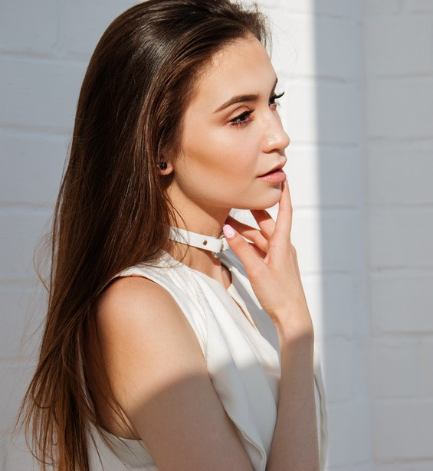Fashion Illustration Drawing Sketch
Digital Fashion Drawing Trend Forecasting
+123-456-7890

hello@reallygreatsite.com www.reallygreatsite.com 123 Anywhere St., Any City

